November 11, 2009

To Whom It May Concern:

We have worked closely with Dr. Tony Alessandra and his wonderful IT team at AssessmentBusinessCenter.com since early 2003.

They helped us develop a turnkey, online assessment business – MyTrueColors.com - that has created a steady and increasing source of passive revenue for our company.

The most (pleasantly) surprising outcome of our work together has been the lack of problems and/or tech support inquiries we have received. We sell thousands upon thousands of assessments, yet we rarely encounter technical difficulties. In the rare occasion that we do have a help desk issue, the speed of response and quick resolution from Dr. Tony’s IT team has been remarkable. Our customers find their system to be intuitive; requiring little or no training on our behalf.

If you are considering a relationship with Assessment Business Center, you will discover Dr. Tony and his IT team to be flexible, versatile, open-minded, experienced and helpful!

I cannot possibly recommend their services highly enough.

Sincerely,
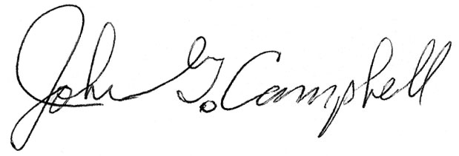
John Campbell, Director
International Business Development
True Colors International

